**NAME:** KENNY IBRAHIM  **AGE:** 30YRS  **LMP: DATE:** 03/05/2021

**REF:**  **HOSPITAL:**

**OBSTETRIC SCAN**

**The uterus is bulky and gravid. A fetal pole with cardiac pulsation is noted within the uterus.**

**BIOMETRIC PARAMETER**

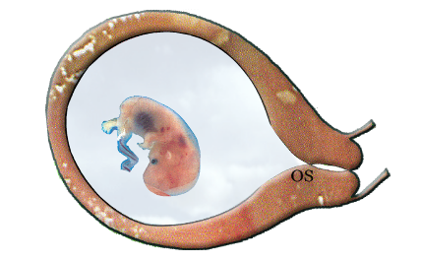**CRL =** 17 mm

**GA=** 8 WEEKS 1 DAY

**EDD=** 12/12/2021 +/- 2 weeks

The cervical Os is closed.

**IMPRESSION: NORMAL INTRAUTERINE CYESIS AT 8WEEKS 1 DAY GESTATION.**

**FOLLOW-UP.**

**REPEAT SCAN AT 18 WEEKS GESTATIONAL AGE FOR FOLLOW-UP.**

**……………………………….**

**ERNEST A.O**

**B.Rad., PGD USS, PGD CT.**